**Networks II – Intermediate Project Report**

George Xu (gx33), James Liu (jjl254), Bella You (my336), (Stephanie Li (sl2326)

Our group is trying to tackle the problem of grouping students for academic projects. The currently used methods include randomly matching students or allowing students to group themselves. However, random matchings do not take into account a student’s preferences and can obstruct a group’s efficiency. Allowing students to group themselves may create imbalances between groups and may also isolate some students. Our question is: can we come up with an algorithm that groups students together efficiently but more productively (ie. most students are just as happy, no students are isolated, and students’ preferences are honored) than random matching or allowing students to group themselves?

To this end, we are hoping to create a thorough and efficient algorithm to group students together based on their strengths, weaknesses, and preferences. The idea is to have students fill out preferences forms and have the professor specify the number of people per group, and perhaps the roles required in each group. Our algorithm would then take these preferences and requirements into account before matching students into groups. The difficulty of this problem comes from understanding how to accurately weigh each preference and also how to efficiently match groups of multiple students.

This problem relates to Networks because we can represent the students as nodes in a graph and the edges as suitable partners. We would then have to create a certain number of connected graphs with these edges where each connected component represents a project group of students.

Our main depth dimension is design, although our project also touches on analysis. Our identification and modeling is fairly standard; students as nodes, with edges. We have made some progress in the design dimension; thus far, we have come up with a rough way of ordering students on each other’s preference lists based on a preference survey, and we are considering methods of matching students based on these preference lists. Some code and comments describing our implementation plans can be found at <https://github.com/BellaYou/Networks-2-project>. In addition, we have come up with a design for some of the main pages of our website, as seen below:

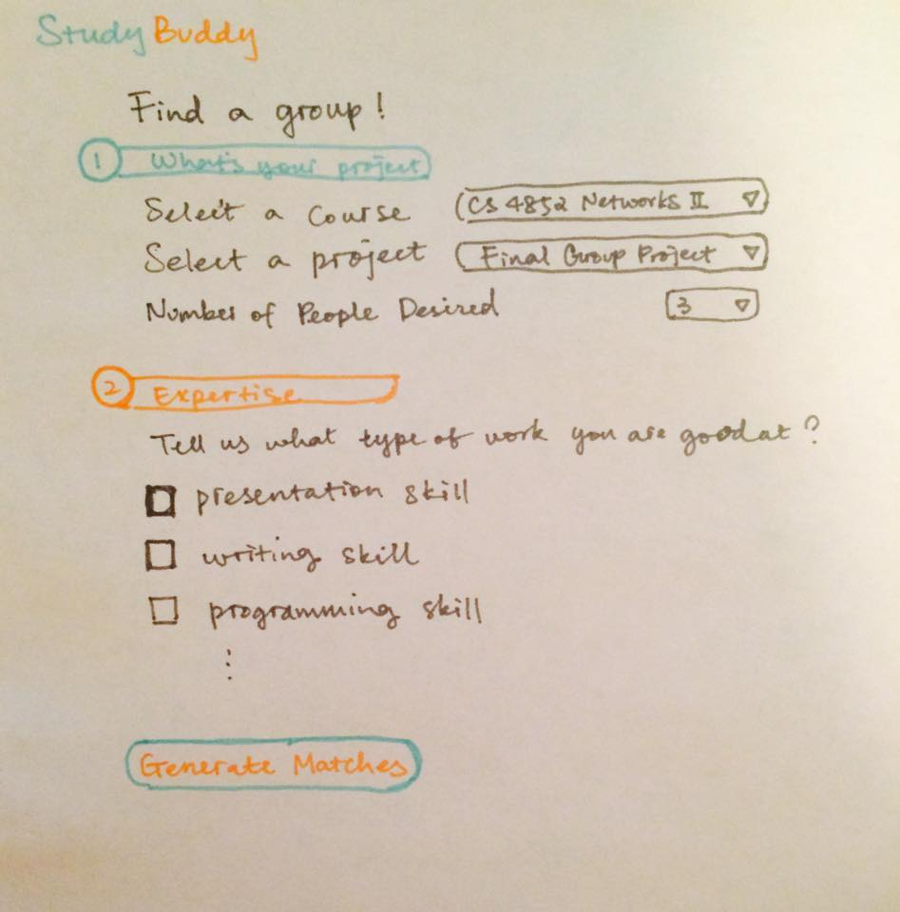 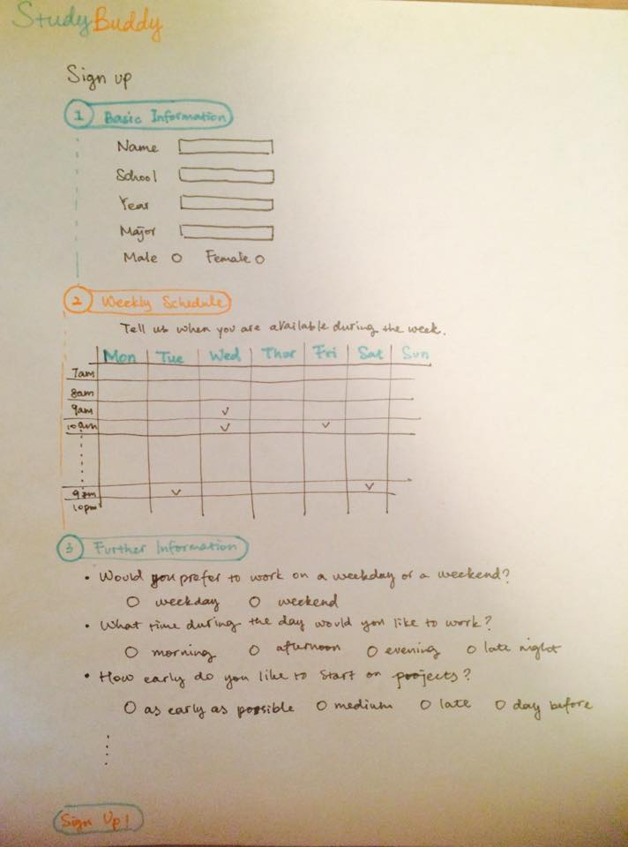

Schedule of future goals:

* Finalize set of attributes, determine how they will be represented
* Design matching algorithm, have pseudocode, determine matching principles
* Implement matching algorithm, fill in skeleton code
* Create UI
* Testing

Some design questions to answer:

-How the questions will be worded/how to represent the users’ choices and use as arguments to matching algo

-How much will professors be able to personalize or customize, i.e. how will they be able to specify group size, or skills required, etc

The next major step is designing the matching algorithm. We want to make use of the idea of stable matchings, but we first need to determine how preference lists will be created.  Our current idea is to use a point system, where for each student, we calculate values for all potential partners based off their survey responses, and use these as the ordering of the preference lists. To do this we need to decide how to weigh the different attributes. We will also rule out all partners with conflicting schedules. Another issue we need to consider is how to deal with variability specified by survey creators. After the algorithm is finalized we will code it in python.

After that is done we will create the UI. As mentioned before, we have several drafts of how we’d like it to appear. This may be adapted based on changes we deem necessary throughout the coding process. After this is done, our last major step will be user testing.